|  |  |  |  |  |  |
| --- | --- | --- | --- | --- | --- |
| Date | 6-Dec-22 | | | Tester Name | Mayuri Patel |
| Environment | Penfax - Test | | | Login used |  |
| Operating System | Select OS | Version: | Update: | | |
| Software Used | Select Software | Version: | Update: | | |
| Select Software | Version: | Update: | | |
| Release version | 22.4.1 | | | | |
| Title |  | | | | |
| Test Type | Regression | | | | |
| Test Scenario | Process 2 lump sum requests the same day | | | | |
|  |  | | | | |
| Expected Results |  | | | | |
| Pass/Fail | Pass | | | JIRA# | N/A |

Describe your steps with screenshots:

1. 1st lump sum payment from Pen fax and 2nd lump sum payment from Pen web

Find any PEPP active member for 2 lump sum payments (1st from Pen fax and 2nd from Pen web) the same day

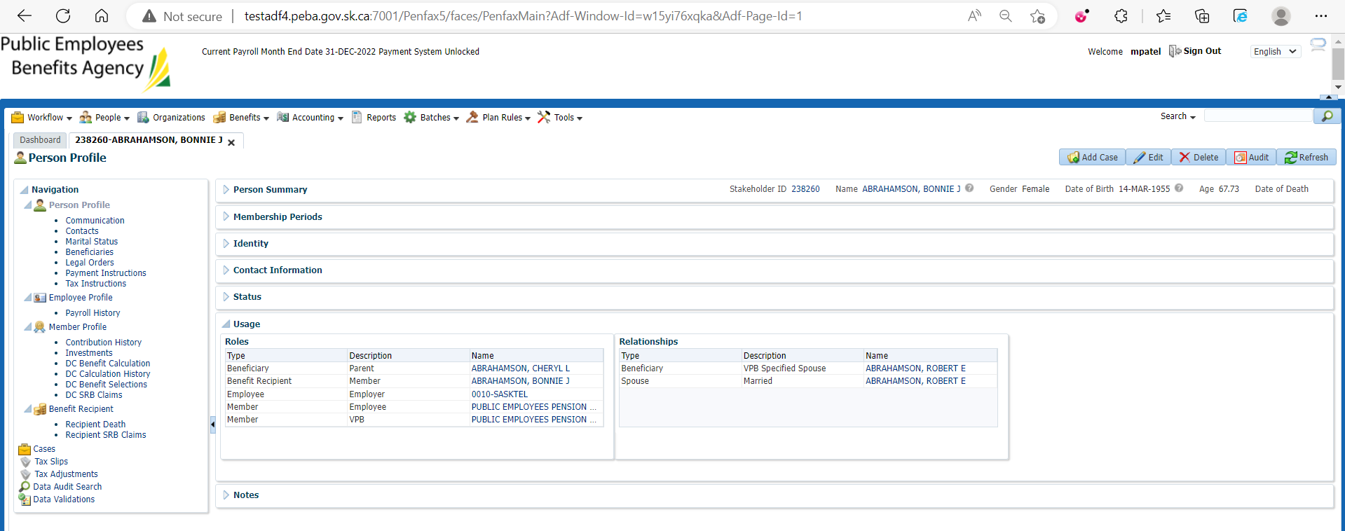

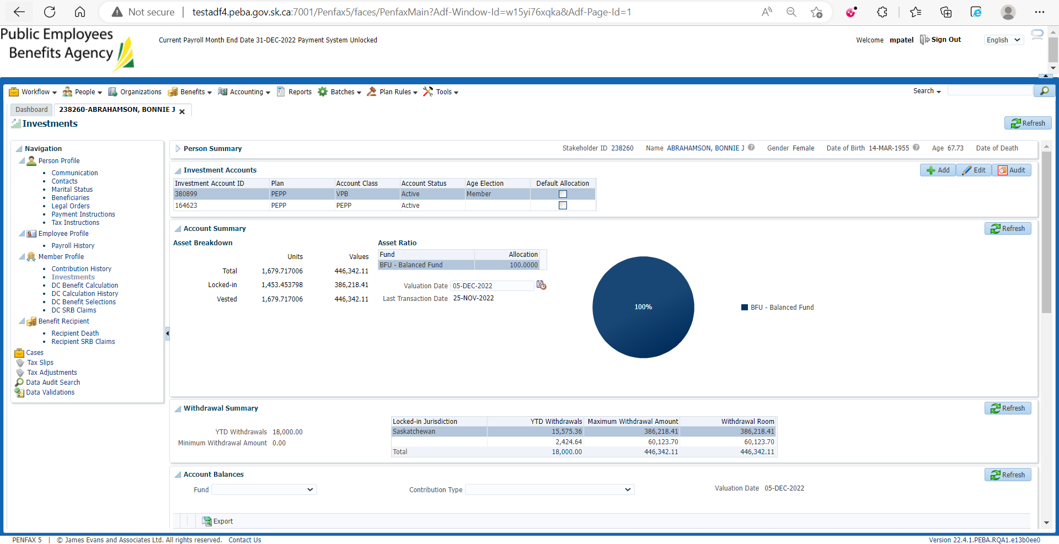

Go to DC Benefit Selection

Add new DC Benefit

Add allocation for lump sum payment and save

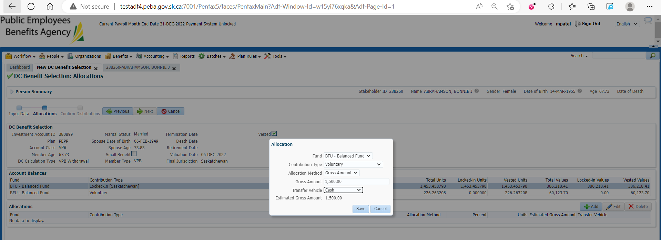

Next

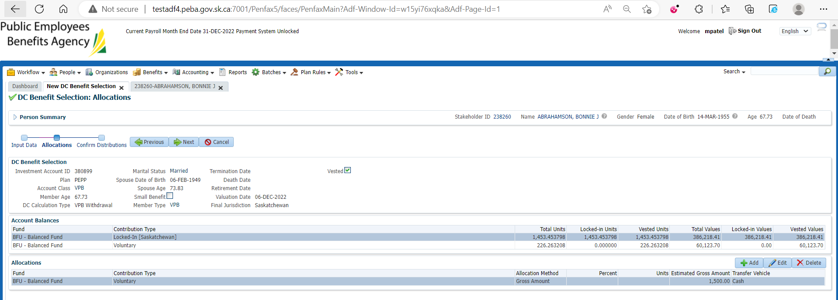

Submit for Approval and Approve it

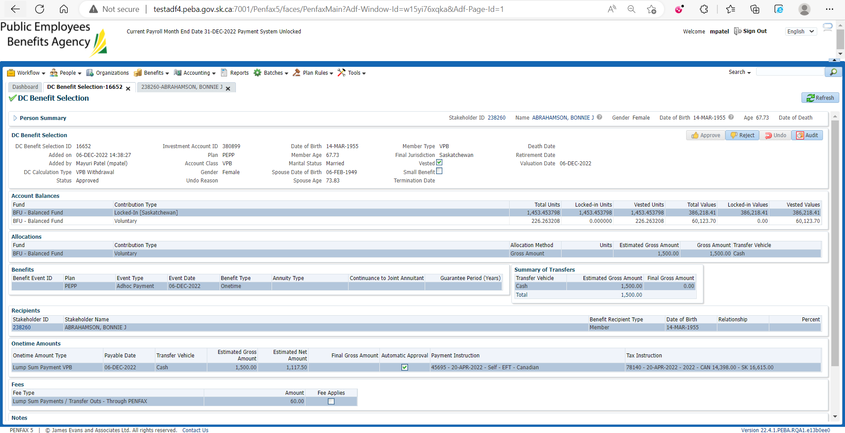

For 2nd Lump sum payment through pen web open that member Profile in Pen web



Request lump Sum payment

Enter Requested payment Amount and Next

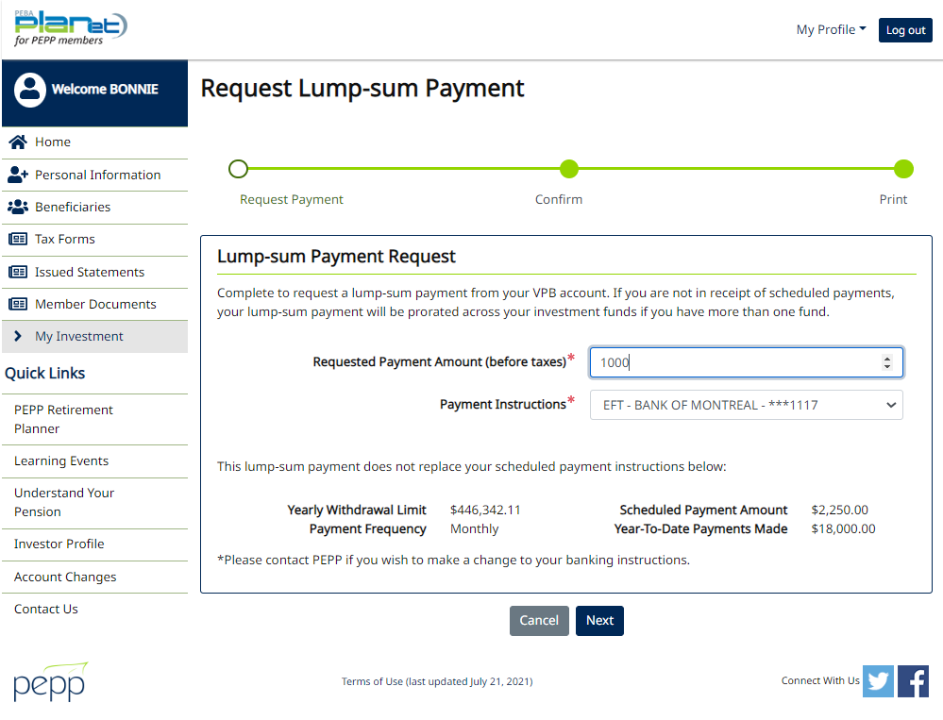

Confirm it

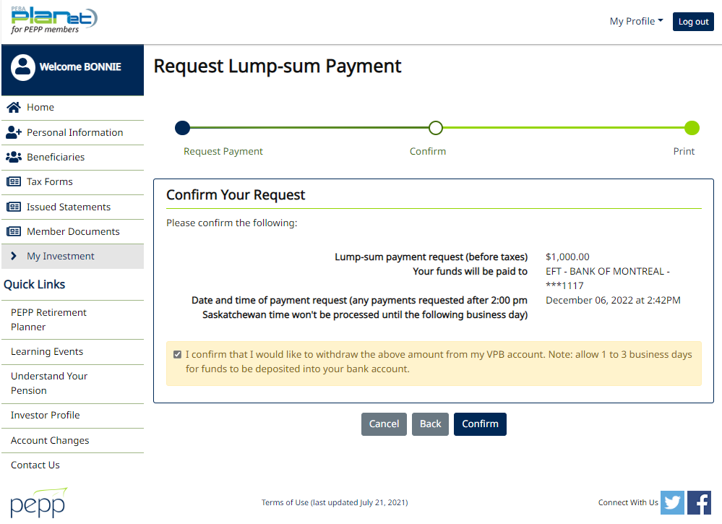

Warning pops up ‘can not process request as a pending transaction exists. Contact PEPP for assistance.’

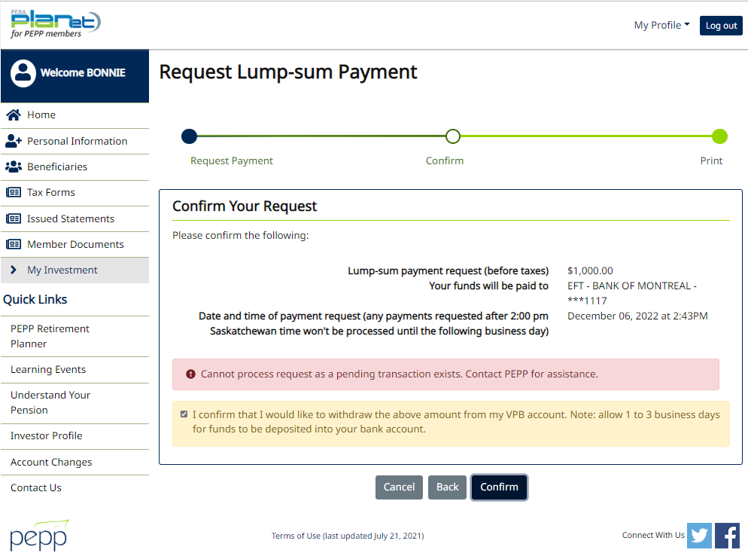

1. 1st lump sum payment from Pen web and 2nd lump sum payment from Pen web

Find any PEPP Active member for 2 lump sum payments through Pen web the same day



Go to My Investment

Request lump sum payment

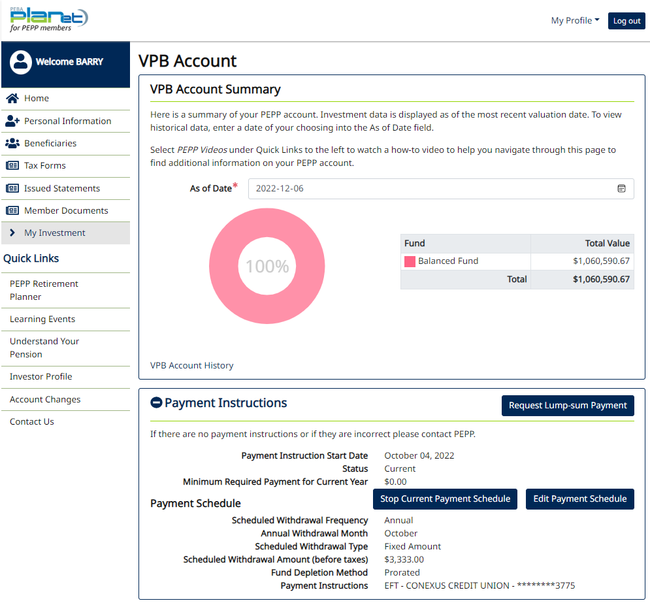

Enter requested payment amount and next

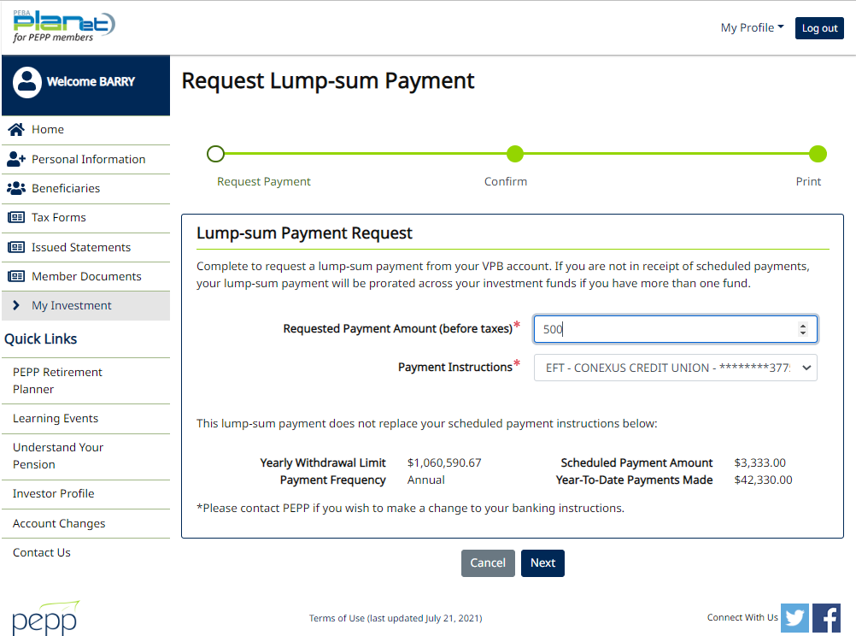

Confirm it

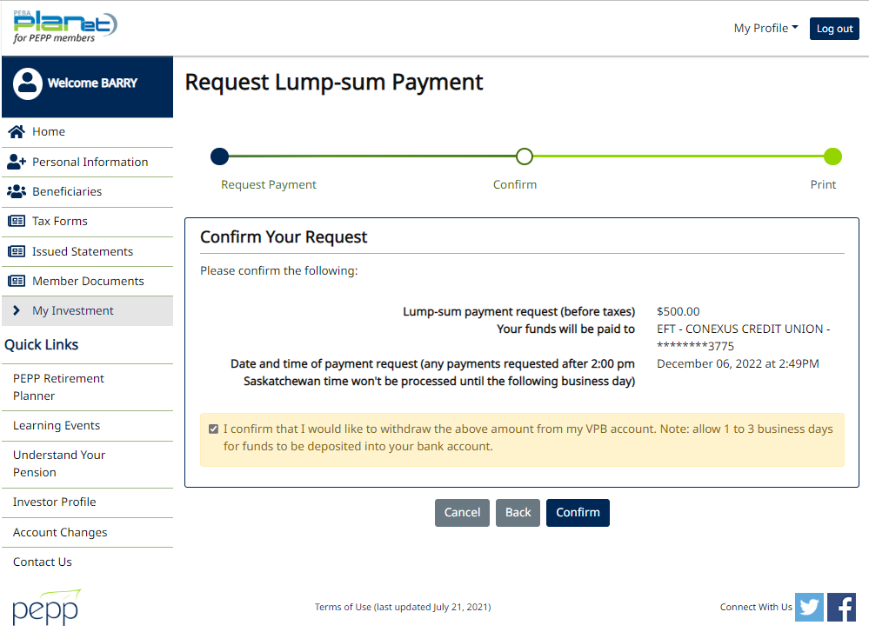

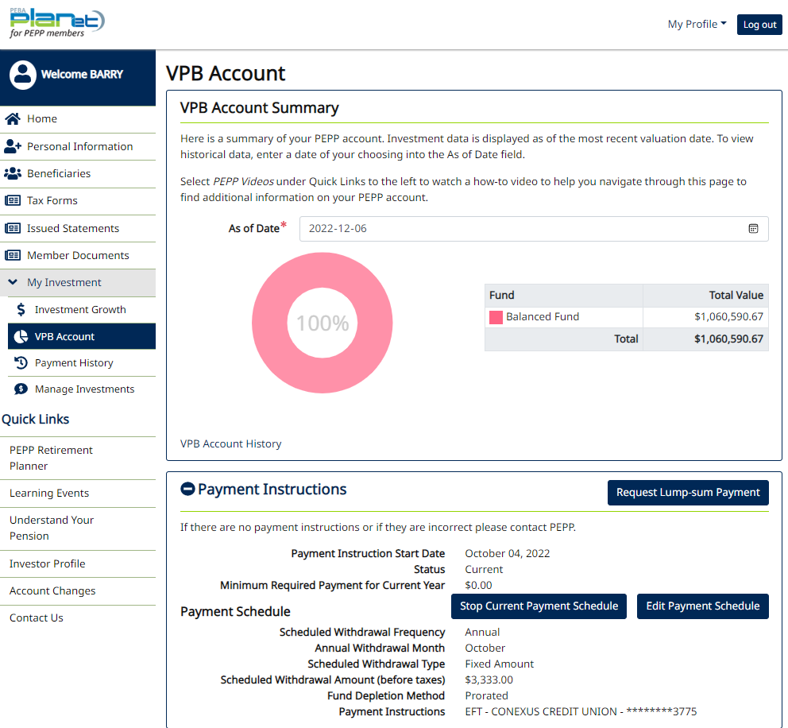

Request another Lump sum payment

Enter Requested payment amount and Next

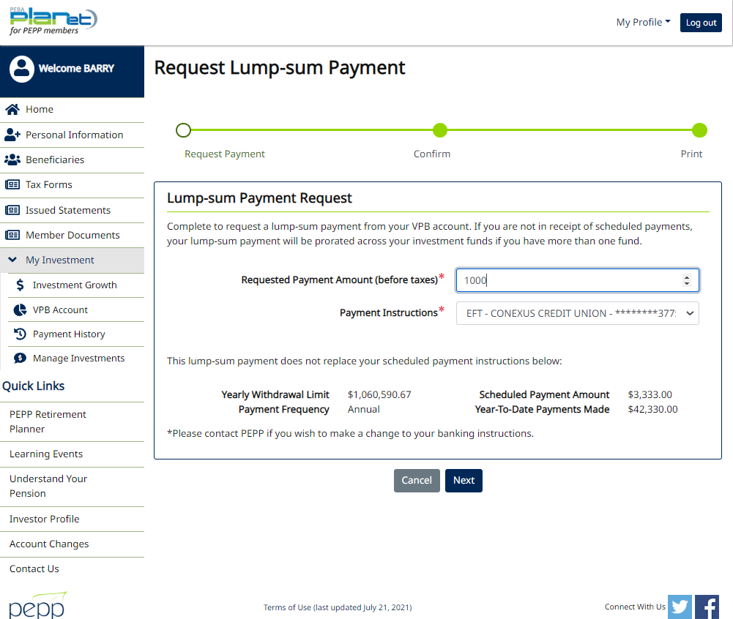

Confirm it

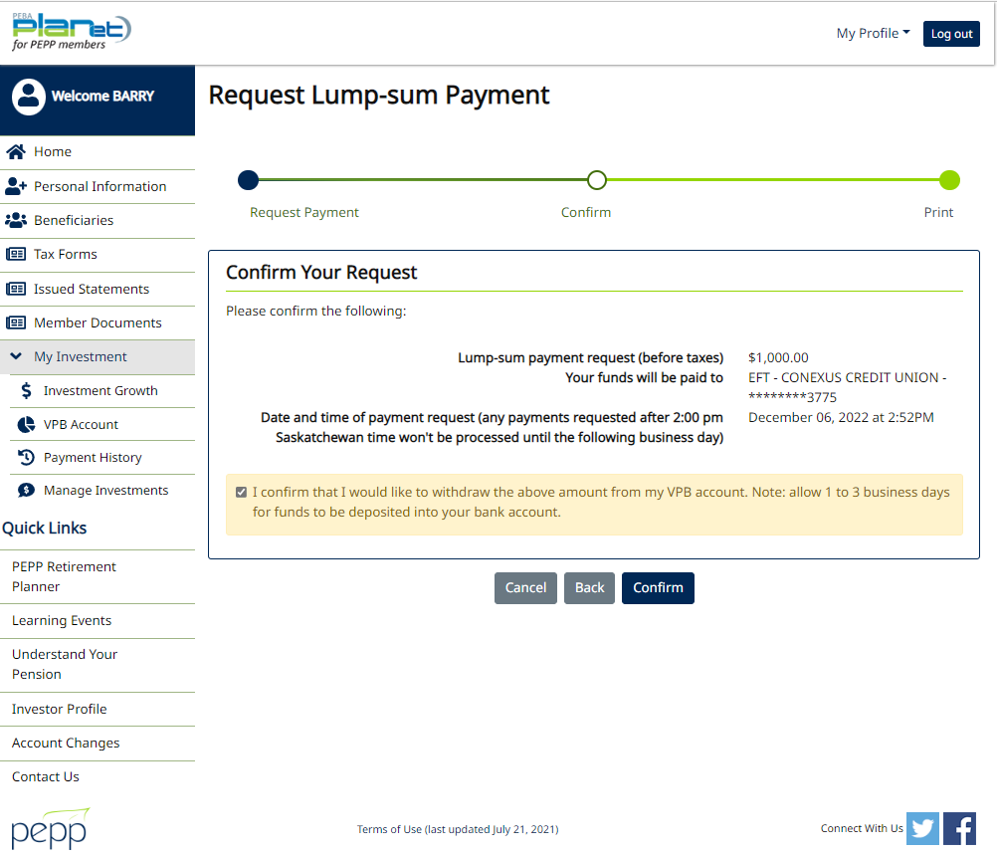

Warning pops up ‘Can not process request as a pending transaction exists. Contact PEPP for assistance.’

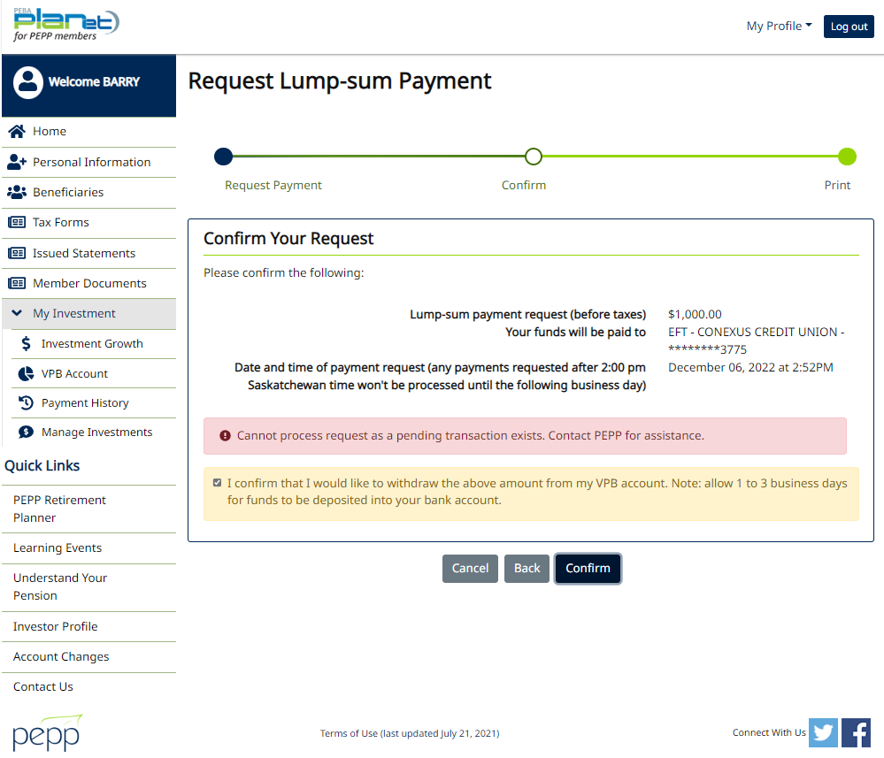

1. 1st lump sum payment from Pen fax and 2nd lump sum payment from Pen fax

Find any PEPP Active member for 2 lump sum payments (1st from Pen fax and 2nd from Pen fax) the same day

Open that member Profile

Go to DC Benefit Selection and add new DC Benefit

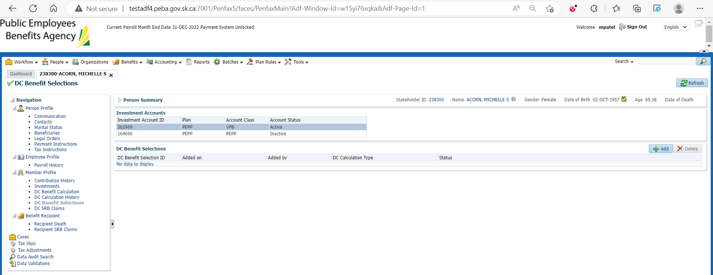

Add allocation for lump sum payment and save

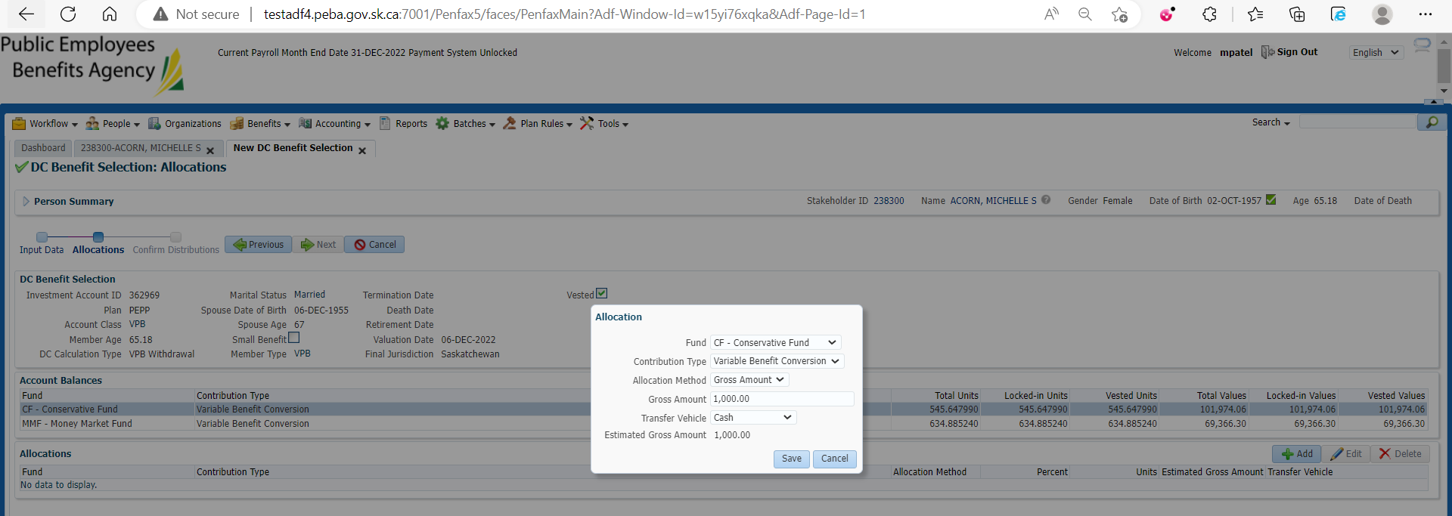

Submit for Approval and Approve it

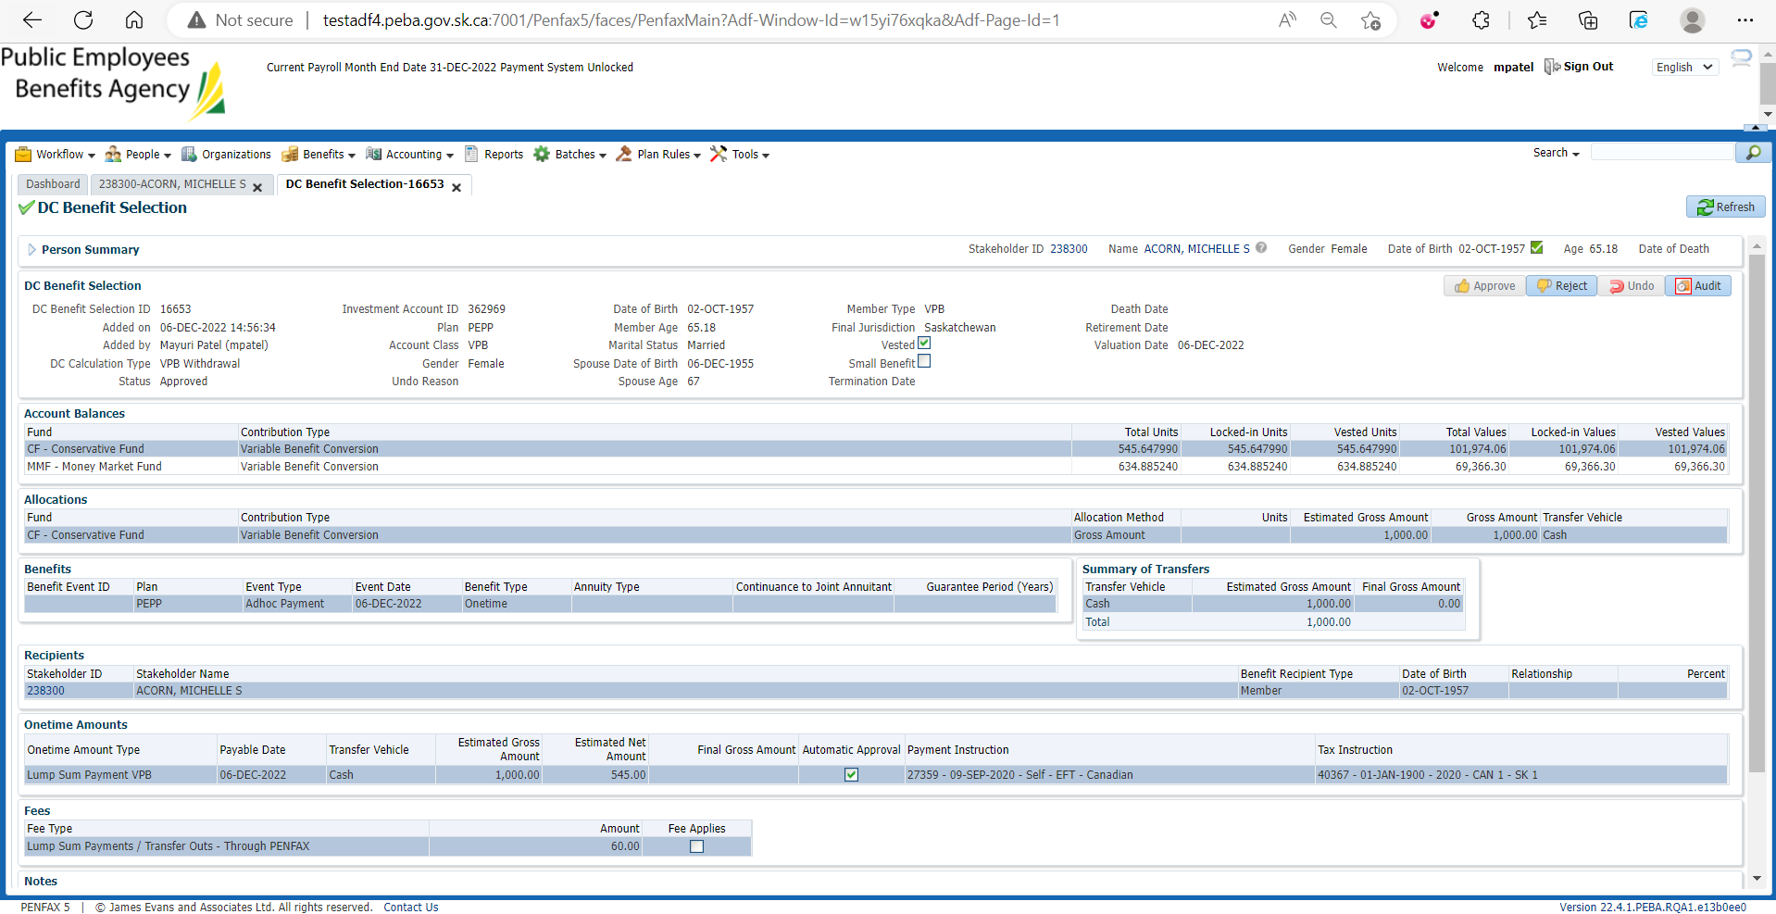

New Benefit Selection is approved



Added New Benefit is now pending under Investments🡪Account instructions

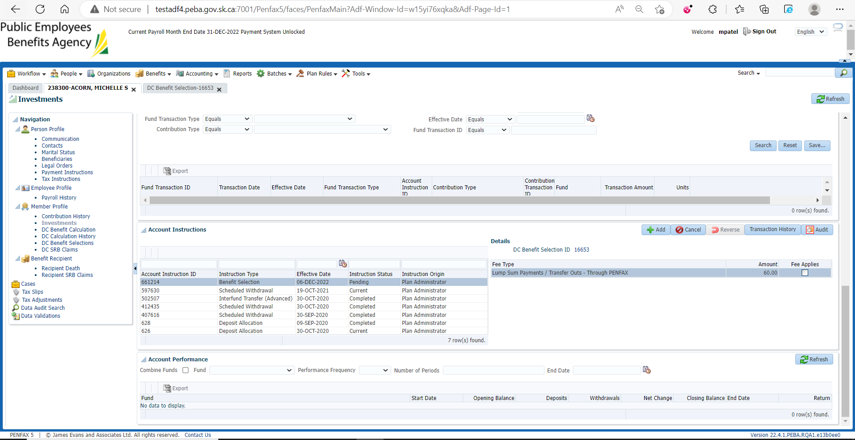

For another Lump sum payment request

Go to DC Benefit Selection again and Add another DC benefit

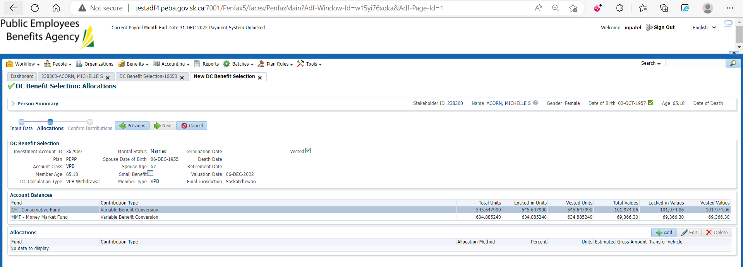

Add allocation for another lump sum payment and save

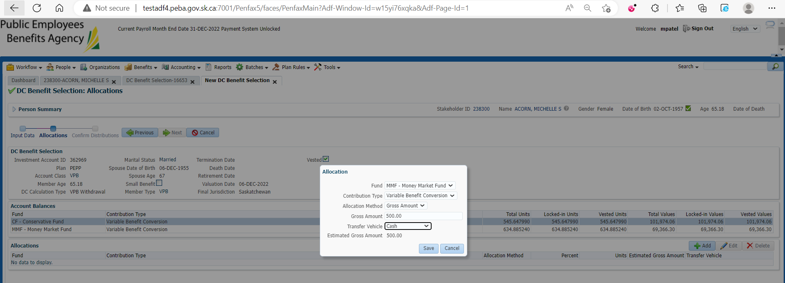

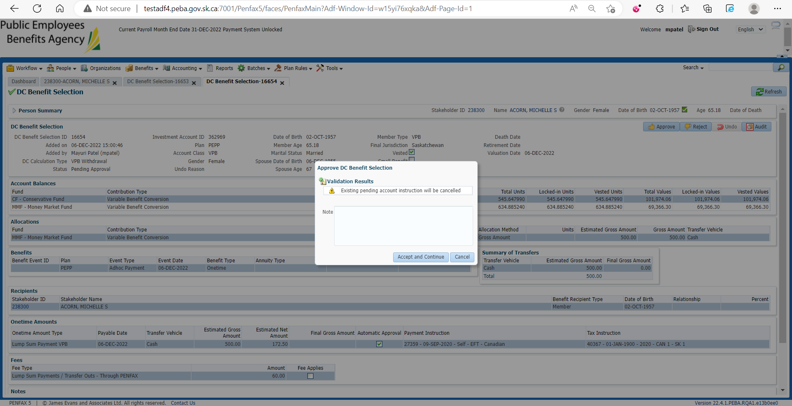

Accept and Continue

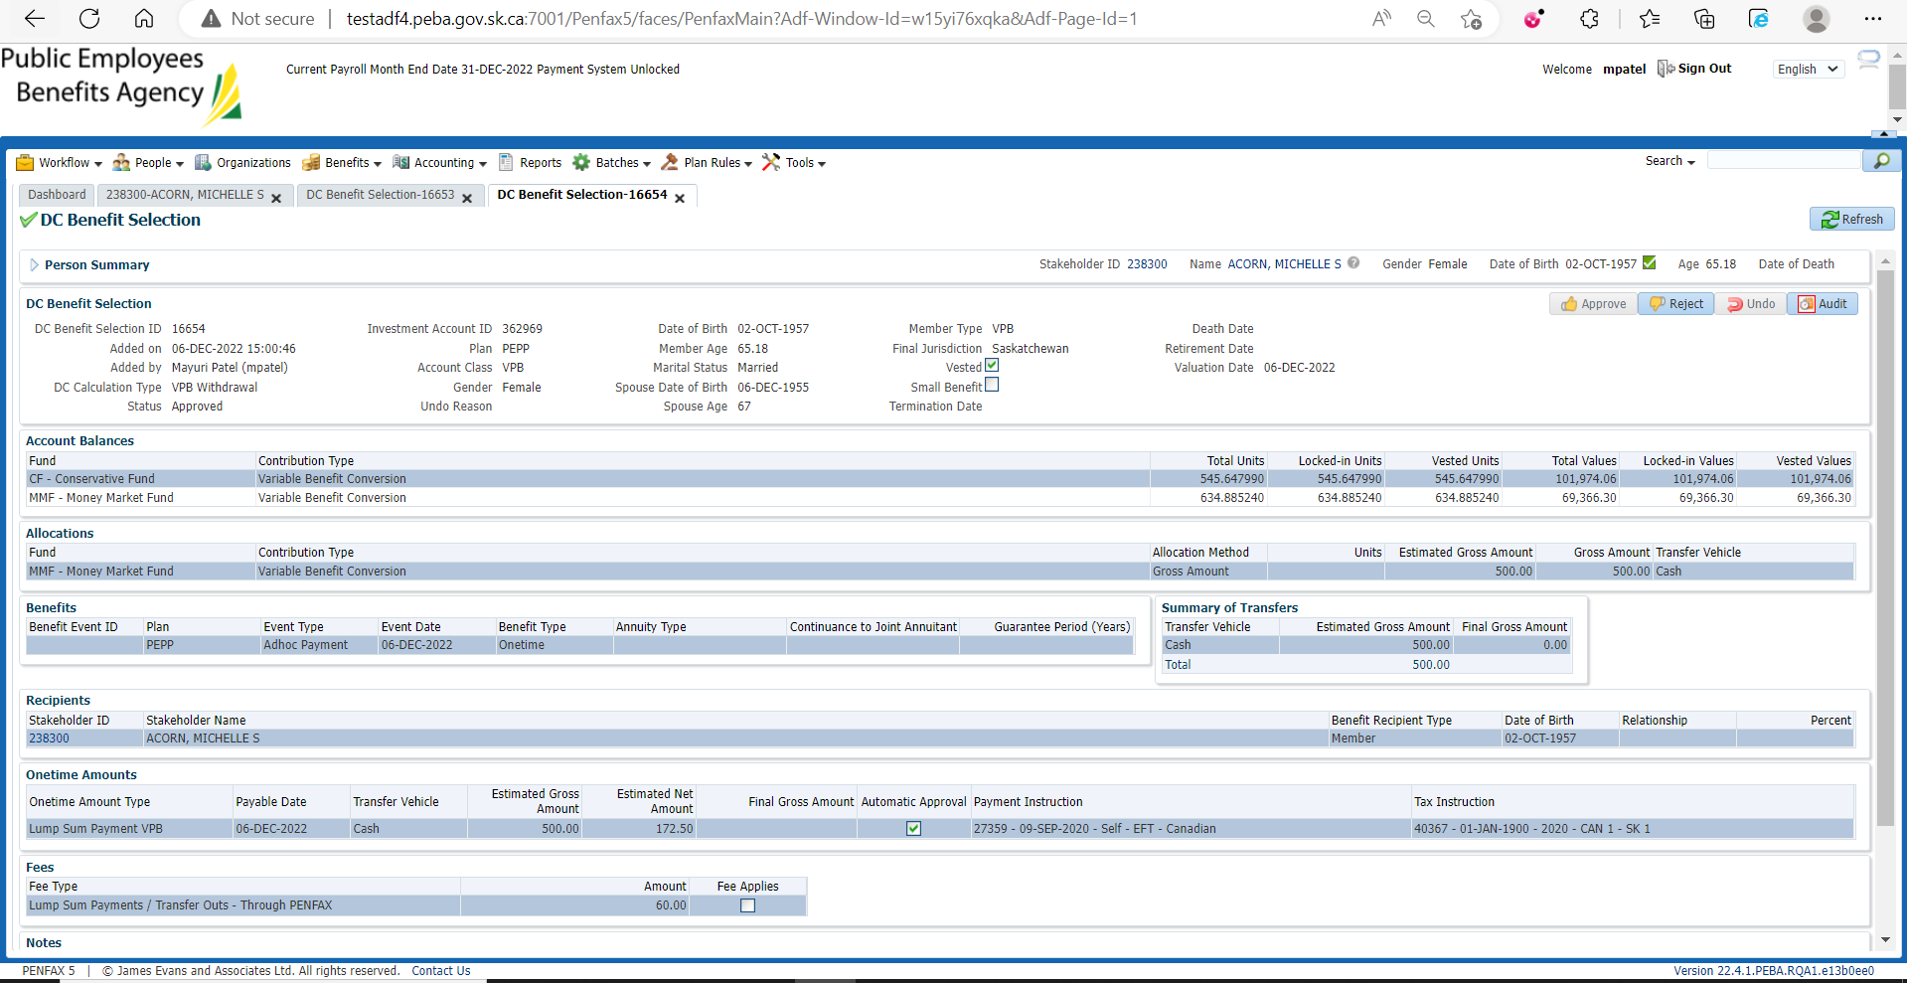

Under Investments🡪 Account Instructions

1st lump sum payment is cancelled and the 2nd one is now pending

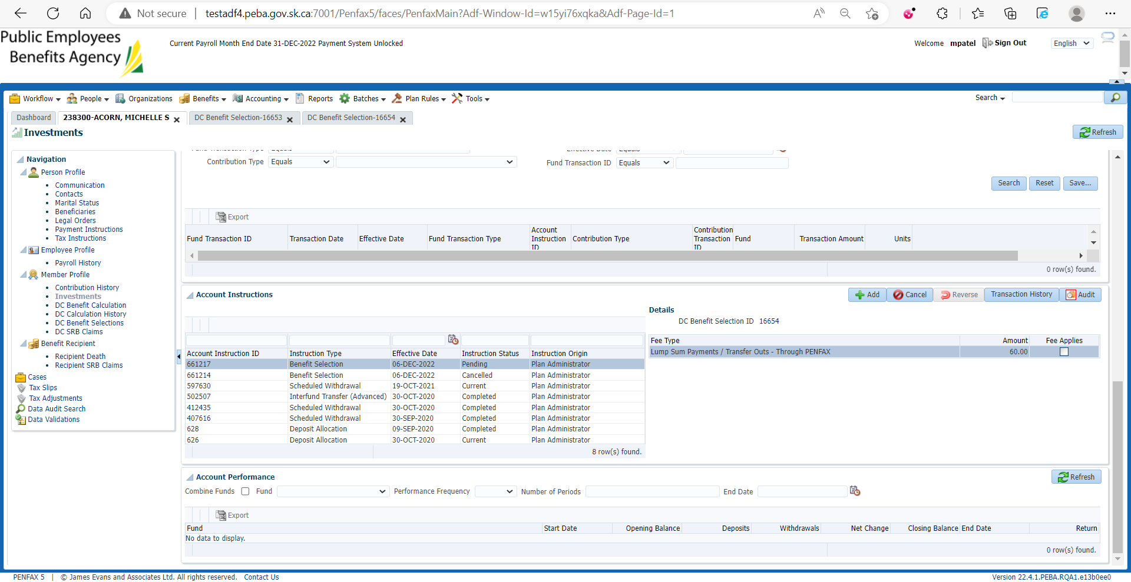

Under DC Benefit Selections

1st lump sum payment request is rejected and 2nd lump sum payment request is approved

